A
Project Synopsis
on
CARE CONNECT

by
GROUP NUMBER
A – 03
GROUP DETAILS

Name of Student | Roll No.
Diksha Vikas Patil | 106
Sadiccha Satish Patil | 113
Paurnima Ananda Shirsat | 114
Vaishnavi Vinod Kamble | 125

Bachelor of Technology
in
Computer Science & Engineering
Under the Guidance of
Prof. V. C. Patil
Assistant Professor


SWVSM’s
Tatyasaheb Kore Institute of Engineering and Technology, Warananagar (An Autonomous Institute)
Department of Computer Science & Engineering
Academic Year 2026-27

Synopsis

- Project Title :- Care Connect

- Guide :- Prof. V. C. Patil

- Area / Domain of Project :- Social Service (SocialTech)

- Introduction :-
CareConnect is a centralized multi-service community support platform designed to connect beneficiaries, volunteers, NGOs and service providers on a single platform. The system focuses on different areas of social service such as education, healthcare assistance, elderly support, food donation, environmental activities, and essential-item support.
In existing systems, social-service activities are often managed separately, making it difficult to identify the right volunteer or organization for a particular need. CareConnect addresses this problem by providing a smart volunteer and NGO matching system based on factors such as skills, location, availability, and urgency.
The platform also allows beneficiaries to raise requests, NGOs to manage resources, and volunteers to accept suitable tasks. A multi-need case management system can handle multiple requirements of the same beneficiary under a single case. Through request tracking, notifications, verification, and an impact dashboard, CareConnect aims to make community service more organized, transparent, accessible, and efficient.

- Motivation :-

The motivation behind developing CareConnect is to provide a single platform where people who need help can easily connect with the right volunteers, NGOs, donors, and service providers. Currently, social-service activities are often scattered across different organizations and communication platforms, making it difficult to find suitable help quickly.There is also a need for better coordination between volunteers and NGOs based on their skills, location, availability, and the urgency of a request. CareConnect aims to address these challenges by bringing multiple services such as education, healthcare assistance, elderly support, food donation, environmental activities, and essential-item assistance together on one platform.
The project is motivated by the goal of making social-service activities faster, better organized, transparent, and accessible, while ensuring that available volunteers and resources reach the people who need them most.
- Existing System :-
The existing system manages social services through NGOs, volunteer groups, donation platforms, social media, phone calls, and messaging applications. Beneficiaries submit their requirements, and NGOs or administrators manually coordinate with suitable volunteers or donors. Platforms such as Seva Setu provide registration, service posting, volunteer selection, and completion tracking.
Working
- User registration
- Service/request creation
- Admin verification
- Volunteer/donor selection
- Service execution
- Completion update
Limitations
- Services are often scattered across different platforms.
- Limited support for multiple needs of one beneficiary.
- Volunteer matching may not consider skills, location, availability, and urgency together.
- Limited intelligent and real-time request prioritization.

- Drawbacks/limitations/challenges in Existing System :-
- Fragmented services across different NGOs and platforms.
- Manual volunteer selection can be time-consuming.
- Limited skill, location, availability, and urgency-based matching.
- Difficult to manage multiple needs of the same beneficiary.
- Limited real-time tracking and notifications.
- Difficulty in verifying volunteers, beneficiaries, and requests.
- Limited centralized records and impact analysis.

- Problem Statement :-
Existing social-service systems lack centralized coordination between beneficiaries, volunteers, and NGOs.
CareConnect connects them through smart matching based on skills, location, availability, and urgency across multiple service areas.

- Proposed Work :-
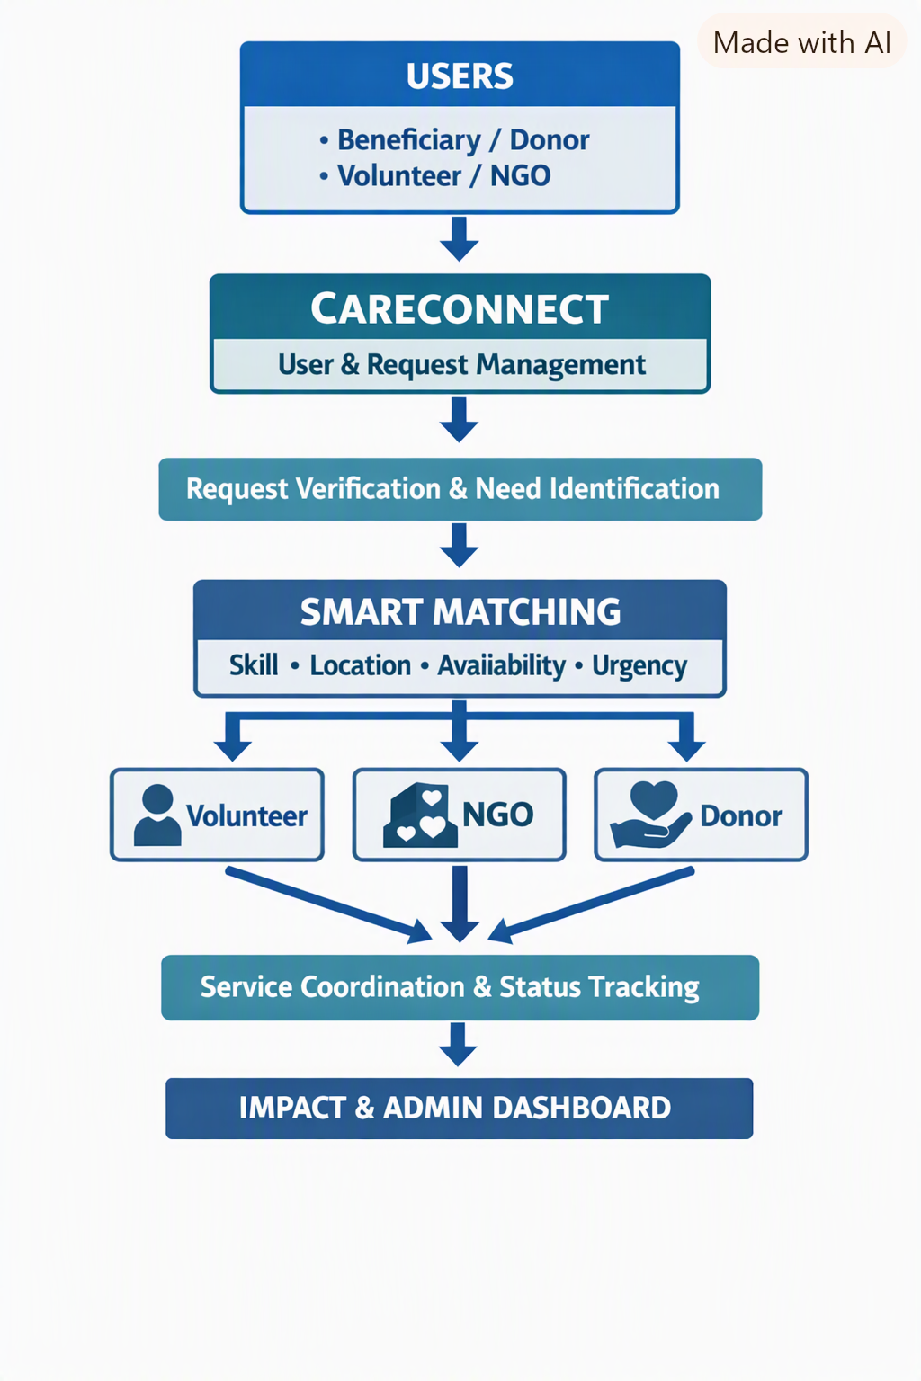
  - Block Diagram :

  - Modules :
The CareConnect system can be divided into the following modules:
- User Management Module – Registration, login, profiles, and role management for beneficiaries, volunteers, NGOs, and donors.
- Request Management Module – Beneficiaries can raise and track requests for different types of support.
- NGO & Volunteer Management Module – Manage NGO details, volunteer skills, availability, and service preferences.
- Smart Matching Module – Matches requests with suitable volunteers/NGOs based on skills, location, availability, and urgency.
- Service Coordination Module – Manages the complete process from request acceptance to service completion.
- Notification Module – Sends notifications about new requests, assignments, status changes, and urgent cases.
- Admin & Verification Module – Verifies users, NGOs, and requests and manages the overall platform.
- Impact & Analytics Module – Tracks completed services, beneficiaries helped, volunteer contributions, and overall social impact.
- Development Environment :-
The CareConnect project will be developed as a web-based application using the following environment:
(1) Software Requirements
- Operating System: Windows 11
- Programming Language: Dart 3.x
- Framework: Flutter 3.x
- IDE: Android Studio
- Database: Firebase Cloud Firestore
- Authentication: Firebase Authentication
- Storage: Firebase Cloud Storage
- Notifications: Firebase Cloud Messaging (FCM)
- Location: Google Maps SDK, Geolocator
- Backend: Firebase
- Version Control: Git & GitHub
- Testing: Android Emulator / Physical Android Device
- Package Management: Flutter Pub
(2) Hardware Requirements
- Processor: Intel Core i5
- RAM: 4 GB,
- Storage: 10 GB space
- Display: 1366 × 768 resolution or higher
- Internet: Required for online services and communication
- Input: Keyboard and mouse

- Deployment Environment :
CareConnect will be deployed as a web-based application accessible through a web browser. The application will be hosted on a web server with a database server for storing user, request, volunteer, NGO, and service information.
Deployment Type: Android Mobile Application
  - Application: Flutter Android App
  - Backend/Database: Firebase
  - Client: Android Smartphone
  - Network: Internet Connection
(1) Software Requirements
- Operating System: Android 8.0 (API Level 26) or above
- Flutter SDK: Flutter 3.35.x
- Dart SDK: Dart 3.9.x
- IDE: Android Studio 2025.1 / Visual Studio Code 1.105+
- Authentication: Firebase Authentication – Latest stable version
- Database: Firebase Cloud Firestore – Latest stable version
- Storage: Firebase Cloud Storage – Latest stable version
- Notifications: Firebase Cloud Messaging (FCM) – Latest stable version
- Location Services: Google Maps SDK / Google Maps Flutter Plugin – Latest stable version
- Location Detection: Geolocator package – Latest stable version
- Internet Connection
(2) Hardware Requirements
- Mobile Device: Android Smartphone
- RAM: Minimum 2 GB
- Storage: Minimum 500 MB free space
- Processor: Quad-core
- GPS: Required for location-based services
- Internet: Stable Wi-Fi or Mobile Data Connection

- References :-
i. Journal / Conference Papers
- eFeed-Hungers 2.0: Pervasive Computing, Sustainable Feeding to Purge Global Hunger, Sustainable Computing: Informatics and Systems, Volume 35, 2022, Article 100694.
- From Waste to Worth: Enhancing Access to Edible Surplus Food Using a Mobile App for Better Distribution, Procedia Computer Science, Volume 269, 2025, Pages 749–761.
- Modeling the Impact of Distributed Ledger Technologies on Food Donations: A Case Study in the Austrian NGO Sector, 2026.
ii. Web References
- Flutter Documentation – Flutter framework for cross-platform mobile application development.
https://docs.flutter.dev/
- Dart Documentation – Dart programming language used for Flutter application development.
https://dart.dev/docs
- Firebase Documentation – Authentication, database, storage, notifications, and backend services for mobile applications.
https://firebase.google.com/docs

iii. Book References
- Simone Alessandria, Flutter Projects, Packt Publishing.
- Alessandro Biessek, Flutter for Beginners: An Introduction to Flutter and Dart, Packt Publishing.
- Marco L. Napoli, Beginning Flutter: A Hands On Guide to App Development, Wiley.

Prof.V. C. Patil Prof. T .H . Patil Dr. R. B. Patil
Project Guide FYP, Coordinator HoD, CSE

